Java project submission report
Name : Yazan Mohammad hassan
ID : 0161943

The UML diagram of the code:
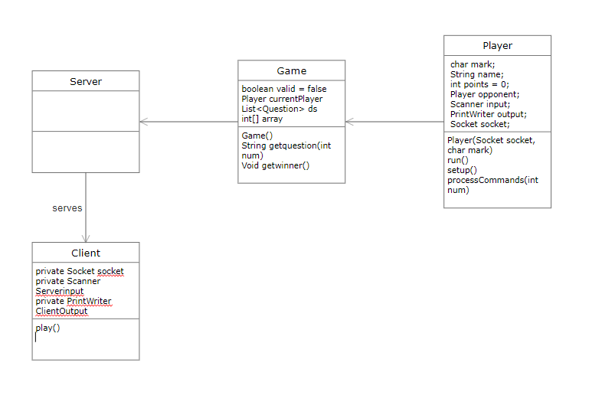
On the server side the code accpets connections from the socket, if a client is already waiting in the lobby it will start the game and send the questions to both of the players.
the game class is the game session that assigns the questions to both the players and sends them. The constructor creates an integer array and then shuffles it so the questions can be random for every game session, the two players will get the same questions but other players in other game sessions will get different questions. The get winner will calculate the winner of the session and sends the result to both players in the game
the player class is the player playing the game. The player constructor will assign the socket to the player and starts the game, the processcommand method will process the user input and see wether the input is the correct answer and alters the point of player, in the run method it will send each player 5 questions.
At the client side it is simpler, at first it will wait for an input from the player which is his name and wait for the server response to start a game or wait for another player to start, the client side of the program only recieves and sends, all the processing of commands is done in the server side.
Known problems in the code is that if 2 players input the same name the server will crash also if a question is correctly answered by one player it will only add the point to the player with the correct answer first but wont move to the next question on the other player side unless they press any key.

